**29-05-22**

**JENKINS**

**Pre-Requisites**

* You need Java JDK-11
* Jenkins Installer

The default URL to access Jenkins is localhost:8080

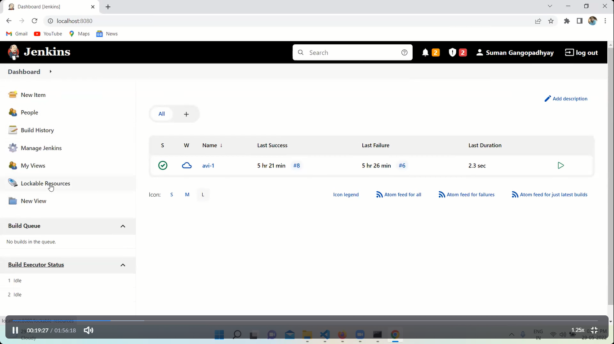

Jenkins dashboard